# Prerequisites

Complete the assembly of the printed circuit boards (PCB) and electric motor wire soldering.

# Tools

3D printer

Wire Stripper for 28 AWG stranded wire

Small Philips head screwdriver

Dupont connector tool

Soldering station with solder/flux

Needle nose pliers

Tweezers

Wire snipper

Multimeter

Breadboard and jumpers for testing electronics

Label maker (optional)

Computer with USB connector

# Software

VS Code

Micropython

# Bill of materials

|  |  |
| --- | --- |
| Item | Quantity |
| Digit 0,2,3 PCB | 3 |
| Digit 1 PCB | 1 |
| Powerbank PCB | 1 |
| A4 Size Felt Sheets with Adhesive Backing, Peel and Stick Felt Sheets Adhesive Backed, Felt Adhesive Sheet | 3 |
| 2 Inch Jumbo Paper Clips (Smooth Big Paperclips) | 20 |
| M2 x 6mm Stainless Steel Phillips Round Head Self Tapping Screws |  |
| M2 x 8mm Stainless Steel Phillips Round Head Self Tapping Screws |  |
| M2 X 15mm Stainless Steel Phillips Round Head Self Tapping Screws |  |
| Micro 130 DC Motor Strong Magnetic Brushed Electric DC 3V -12V 25000 RPM Cars Toys Electric Motor, High Speed Torque DIY Remote Control Toy Car Hobby Motor, Metal Car Engine Motor Kit for Toys | 30 |
| 28 AWG Gauge Flexible Silicone Rubber Electric Wire 6 Colors 32.8 feet each | 1 |
| Dupont Jumper Wire Cable Female Pin Connector 2.54mm | 100 |
| 2.54mm 1x2p Dupont Connector Housing Female for Dupont Cable and Jumper Wire | 100 |
| Digital Temperature and Humidity Sensor DHT11 LED Module, 3 pin | 1 |
| 5mm 0.5 Ω ohm Photoresistor LDR Resistor 5516 GL5516 Light-Dependent Photoconductor (Photo Light Sensitive) | 1 |
| 5mm Flat Top LED Diode Lights (Clear Transparent Lens) Bright Lighting Bulb Lamps Electronics Components Indicator Light Emitting Diodes | 112 |
| 3mm Flat Top LED Diode Lights (Clear Transparent Lens) Bright Lighting Bulb Lamps Electronics Components Indicator Light Emitting Diodes | 2 |
| Vertical Slide Switches Micro High Knob 3 Pin 2 Position 1P2T SPDT Panel Mount AC 125V 2A | 1 |
| 2.54mm 0.1" Pitch PCB Mount Screw Terminal Block Connector, 2P 3P 4P Terminals 150V 6A for 26-18AWG Cable | 1 |
| LM2596 DC-DC Step Down Variable Volt Regulator Input 3.2V-40V Output 1.25V-35V Adjustable Buck Converter Electronic Voltage Stabilizer Power Supply Module | 5 |
| 2.1mm Barrel Jack 5.5x2.1mm Female DC Power Jack 2.1 X 5.5mm DC Jack Connector 6V 9V 12V DC Jack Panel Mount | 1 |
| 12V 5A Power Supply, Waysse Power Supply Adapter, AC DC Converter 100-220V to 12 Volt 5 Amp Transformer 5.5x2.1mm Plug | 1 |
| S8050D S8050 NPN Transistor TO-92 20V 700MA 1W | 1 |
| 1N4001 Diode, standard, 1A, 50V, DO-41 | 1 |
| (optional) 20pin x 10pcs Female Headers Pins Straight Single Row Gold Plated Pitch 2.54mm 0.1 inch for PCB Connector Machine Breadboard Electronic Circuit Board | 10 |
| SONGLE SRS-05VDC-SL 05VDC-SL 4100 Blue 5V 6PIN Power Relay Original | 1 |
| L293D 16-pin IC Stepper Motor Drivers Controller | 17 |
| 0.1uF Ceramic Disc Capacitor - 50 Volts | 5 |
| 1uF Electrolytic Capacitor 1UF-50V-5X11 | 5 |
| SS8550 TO-92 PNP Transistor | 1 |
| 2N2222 TO-92 - NPN Transistor | 1 |
| 10K ohm Resistor 1/2w (0.5Watt) ±1% Tolerance Metal Film Fixed Resistor | 2 |
| Vertical Slide Switch Micro High Knob 3 Pin 2 Position 1P2T SPDT Panel Mount AC 125V 2A | 1 |
| Raspberry pi 2040 pico | 4 |
| Raspberry pi 2040 pico-W | 1 |

# Face assembly

Print the display faces following the table of FDM settings below and press together.

Table 1. Display Face FDM settings

|  |  |  |
| --- | --- | --- |
| File Name | face-digit0-1.stl | face-digits2-3.stl |
| Description | Right side of display face  (when viewed from front) | Left side of display face  (when viewed from front) |
| Material | PLA | PLA |
| Color | White | White |
| Size | 1.75mm | 1.75mm |
| Temp (C) | 190-210 | 190-210 |
| Quantity | 1 | 1 |
| Per unit (g) | 340 | 315 |
| Plate | Smooth | Smooth |
| Layer Height | 0.2 mm | 0.2 mm |
| Infill | 50% | 50% |
| Infill Pattern | Grid | Grid |
| Enable Support | Yes | Yes |
| Ironing | Top Surfaces | Top Surfaces |

Below are few guidelines to keep in mind when printing and assembling the display face:

* The display face uses over 2/3rds of the 1 KG roll of filament. Therefore, be sure to use the same roll of filament when printing both halves of the display face. Also, have two 1 KG rolls of white filament from the same batch to avoid inconsistencies in your print color.
* The infill should be 50% or greater to avoid light leaching from the segment LEDs or from the backside of the display face. I suggest you use a grid infill pattern only for speed and efficiency. I don’t think the infill pattern makes much of a difference.
* Don’t use any glue as it isn’t necessary and may make a mess.
* Don’t worry if your 3D printer and slicer can’t iron the top surfaces. Ironing the top surfaces is for fit and finish and won’t affect the functionality of the display.
* Make sure you add an adhesive to the printer plate bed otherwise the edges and corners of the display face may warp. I used all weather Aqua Net, super hold hair spray which provides an even coating of adhesive across the entire surface of the bed plate.

Figure 1. Back view of the display face

* From the back view of the display face, the left face piece (from left to right) are digits 0, 1 then the colons. The right face piece (from left to right) are digits 2 and 3. When viewing the assembled display face from the back, digit 0 is the left-most digit whereas digit 3 is the right-most digit. Consider adding a label above each digit.
* Allow the display face to thoroughly cool (give it 30 minutes) before removing it from the printer.

# Gasket and Digit PCBs Assembly

Print the gaskets and assemble with the PCBs using M2x8mm self-tapping screws. Each digit PCB will have two, 28 AWG stranded wires that need to be long enough to reach its corresponding buck converter.

Table 2. Digit gaskets FDM settings

|  |  |  |
| --- | --- | --- |
| File Name | digit-colon-gasket.stl | digit-gasket.stl |
| Description | Colon/Digit PCB gasket | Digit PCB gasket |
| Material | TPU | TPU |
| Color | Black | Black |
| Size | 1.75mm | 1.75mm |
| Temp (C) | 190-210 | 190-210 |
| Quantity | 1 | 3 |
| Per unit (g) | 39 | 20 |
| Total (g) | 39 | 60 |
| Brand | Colorful (Flexible) | Colorful (Flexible) |
| Plate | Smooth | Smooth |
| Layer Height | 0.2 mm | 0.2 mm |
| Infill | 50% | 50% |
| Infill Pattern | Grid | Grid |
| Enable Support | No | No |
| Ironing | None | None |

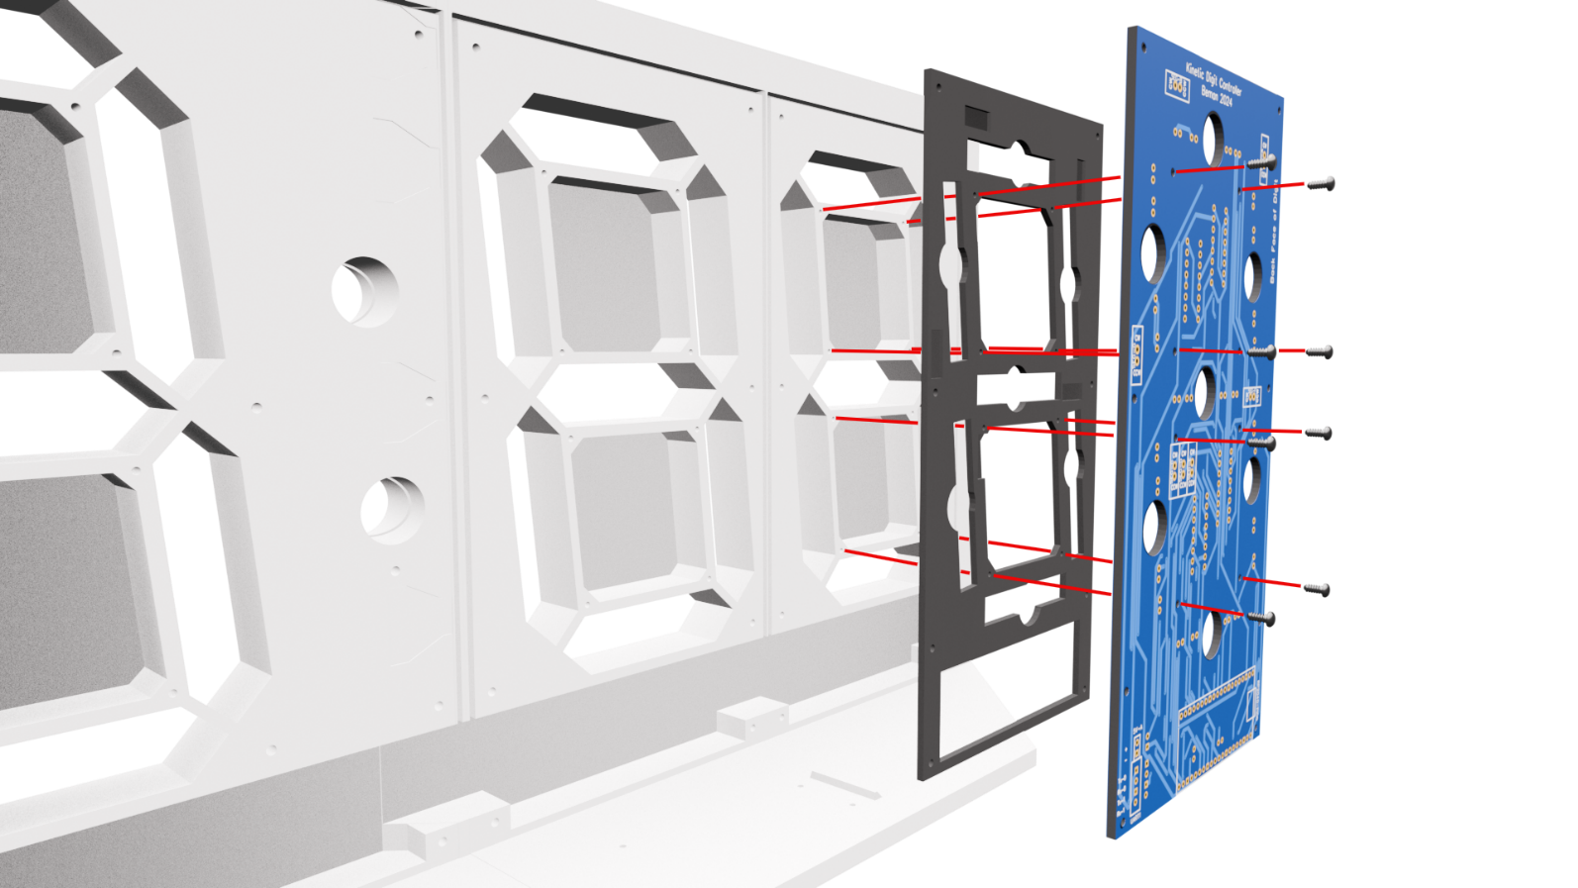

Figure 2. Add digit 0, 2, and 3 gaskets and the digit PCBs* to the back of display the face

*Note this diagram doesn’t display the PCB completed with the components soldered onto the board. At this stage you should have completed the soldering and testing of all components onto the PCBs.

Figure 3. Back of the display showing assembled digits 0, 2, and 3 with gaskets

Figure 4. Back of the display showing the assembly of digit 1 and colons with gasket

# Motor mount assembly

Print 30 motor mounts and 30-toothed gears using the settings in the table below.

Cut 30 20mm shafts from the straight sections of large paper clips.

Following the diagram below, discard the section in red printed with the motor mount. Insert the 30-tooth gear with the 10-tooth reduction gear facing the motor mount. Slide the shaft into the outer collar, through the 30-tooth gear, and into the collar on the inside of the motor mount. Using a soldering iron set to 250ºC, melt the outer collar over the end of the shaft to prevent it from working out of the motor mount.

Figure 5. Motor mount assembly, red section is discarded

# Schematics for Digits 0, 2 & 3

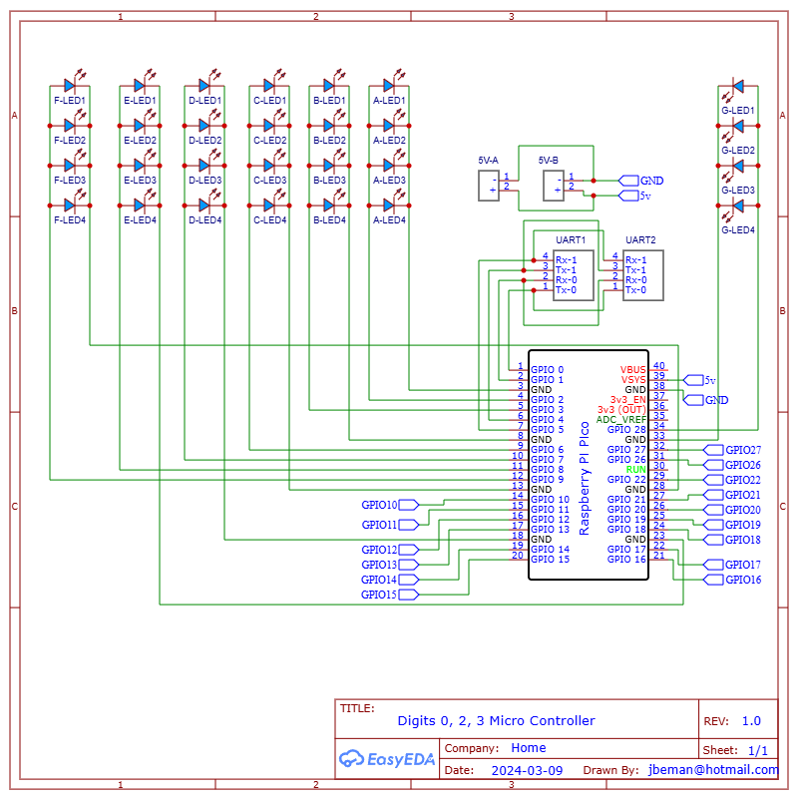

# PCB for Digits 0, 2, 3

# Schematics for Digit 1 and Colons

# PCB for Digit 1 & Colons

